SmartSimple Profile Instructions

Once the registration process is complete, you will receive an email with login instructions. The first thing you will want to do when you log in is update the password. Please make a note of it. Arts Midwest is unable to retrieve the password but we can help you reset it, if needed.

After you login you will come to the home screen. The first thing you will want to complete is the “Organization Profile” and “My Profile” in the “Your Information” section at the top. Use this set of instructions as a guide, there are also tool tips within the system to help you along the way. If you feel stuck at any time, feel free to call or email Arts Midwest for assistance.

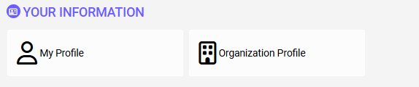

Organization Profile
To begin the process, click on the “Organization Profile.” This will need to be filled out completely so the information will be pulled into any applications you start.
Please only enter your mailing address in the address field. Click “Address Book” to make changes. The address that is present here initially is from the IRS lookup which you completed during the registration process. Once you make updates, click “Save” or “Save Draft” at the bottom of your screen.
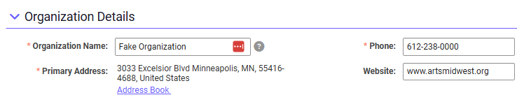

My Profile
To begin the process, click on “My Profile.
Complete the contact information form, many lines will have auto filled from the registration process. Once you make updates, click “Save” or “Save Draft” at the bottom of your screen.

Using SmartSimple
Once the profile information is complete, click on the Arts Midwest logo at the top left of your screen to take you to your Home page. From this screen you can access your account information, view grant opportunities, edit draft applications, submit reports, and communicate with Arts Midwest staff.
The “Applications” section provides a list of available grant programs you may be eligible for. To begin an application, simply click the “Begin a new application” tile. Be sure to download the program guidelines, read them carefully, and begin the process early.
If you already started an application or want to check the status of an application, click on the “Resume an application in progress” tile.

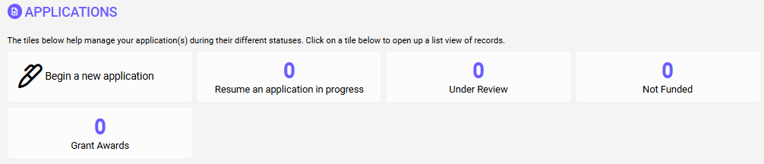

The most important thing to remember, is if you have questions, don’t hesitate to contact Arts Midwest at grants@artsmidwest.org.

