SmartSimple Registration Instructions
Link to grants portal: https://artsmidwest.us-1.smartsimple.com/
SmartSimple is the online grant management software for Arts Midwest. All applicants will use SmartSimple to apply for and manage their Arts Midwest grants. If applicants have never logged in to the system before they will need to register.

1. Below is the login screen. Click “Register” to begin the registration process.
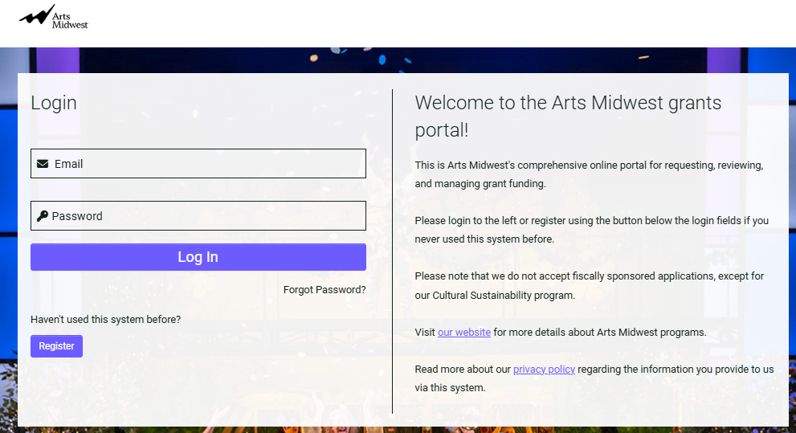

2. On the next screen please click the most appropriate registration option for your organization. Most applicants should choose “Registered Non-Profit Organization” to apply for grants to organizations. The following instructions will apply to users who select this category. All other users will receive instructions in the system as they proceed through the registration process.
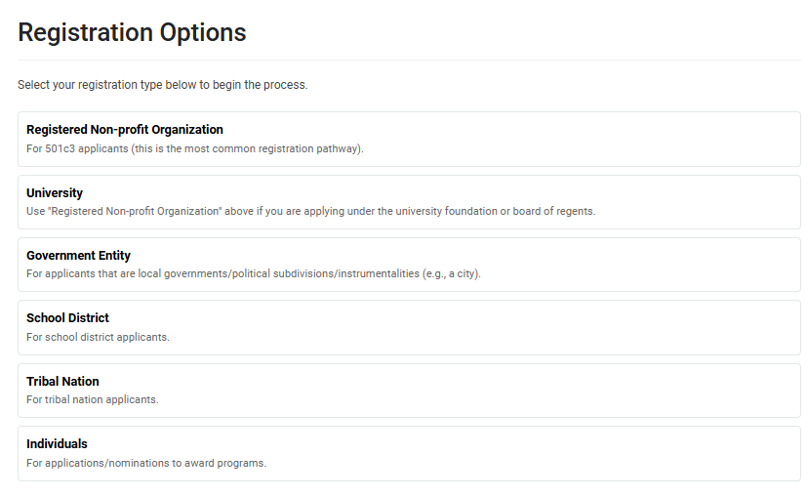
3. Look up the Nonprofit Organization by entering in the Organization’s Employer Identification Number (EIN) then click “Search”. You can also search an organization by its name. Tip: the best way to look up is to enter the EIN only.
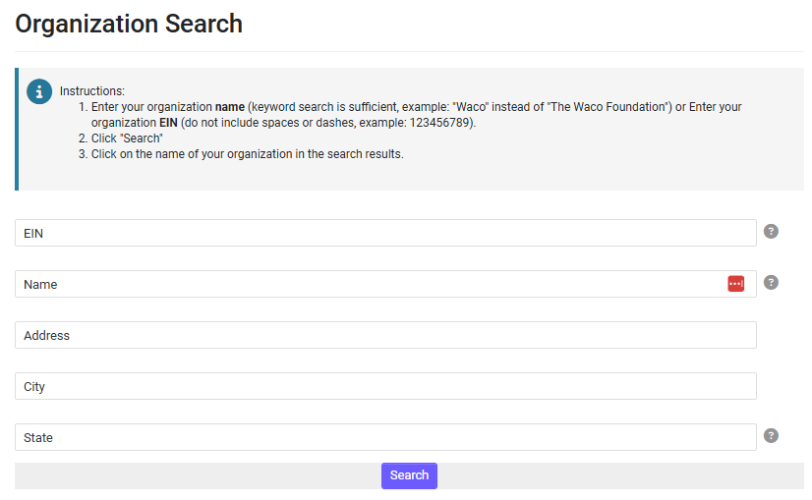

4. Matches to the organizational information provided will be pulled from the IRS database. If the correct organization is listed, click on the organization name. If the organization name is not correct, then you will want to click “Refine Search” and search again.
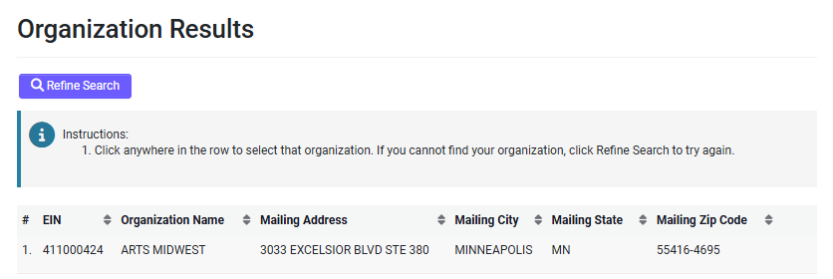
5. Next, you will complete the organization’s information and the contact information. Some of the fields will auto populate from the IRS database cannot be edited at this time (but they can be edited once you log in, if needed). Please double-check all the information is current and correct. Please add your information in the User Information section below on the page. Once all the information is entered, click “Submit”.
6. At this point, the initial registration is complete and you should receive an email at the address you provided to activate your account.
Additional contacts for your organization may register using these same steps, but we recommend adding grant writers and persons external to your organization as “collaborators” on an application. This can be done once you login and start an application.
When you are in an application, look to the left sidebar to find the “Collaborators” option and follow the on-screen instructions.
